Experiment No.:06

Aim: Implementation of Binary Tree and its Traversal for real-world application.

Programs & Outputs :

/\* \*\*\*\*\*\*In-order Traversal\*\*\*\*\*\* \*/

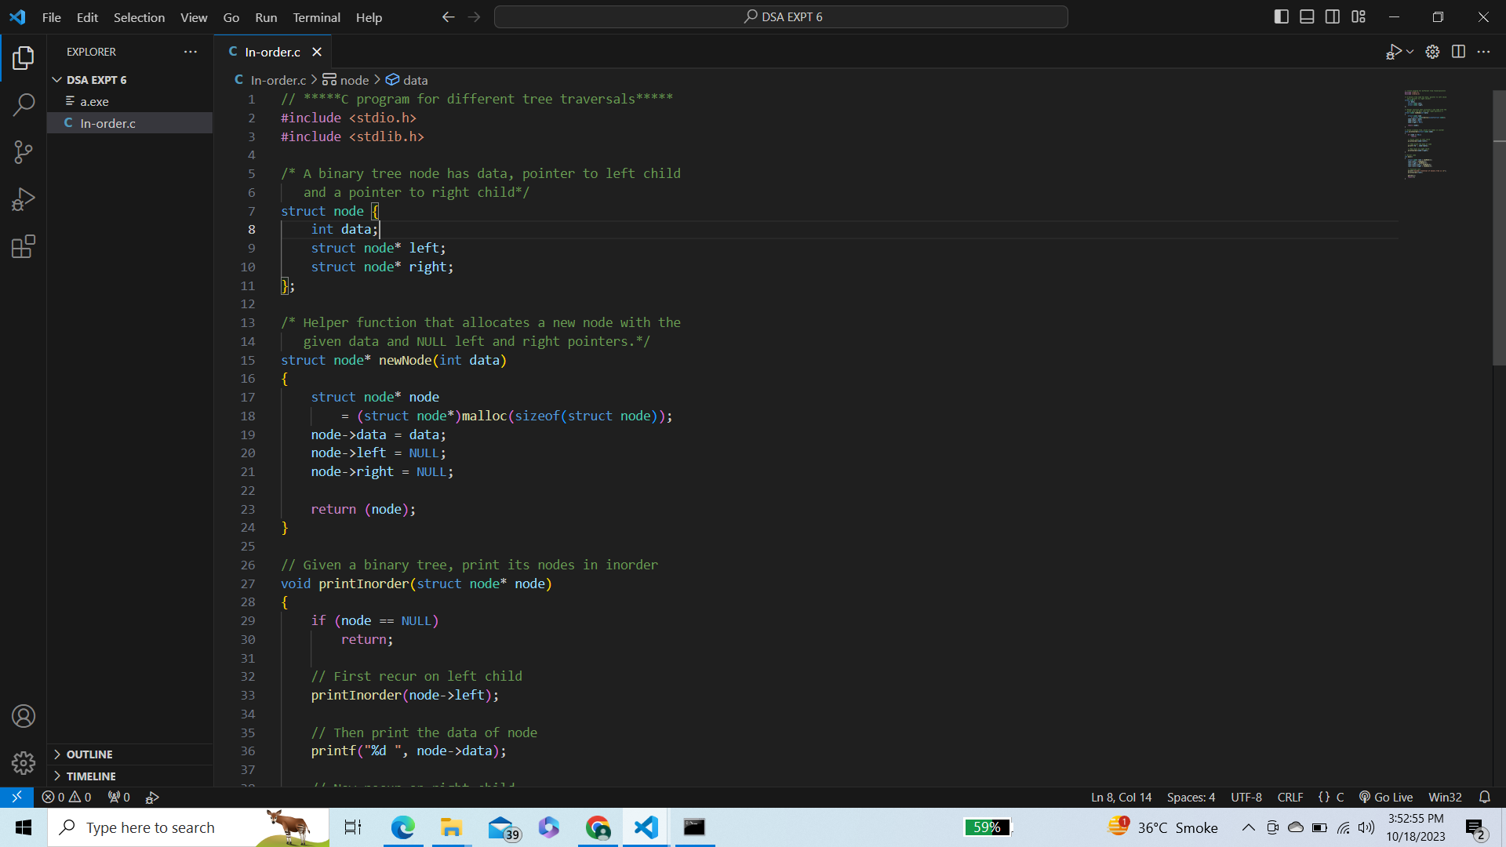

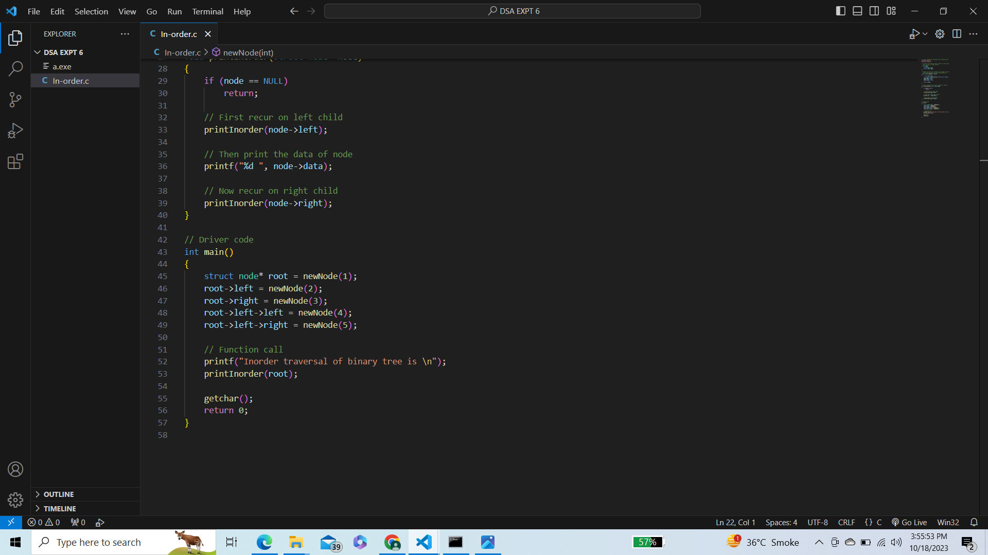

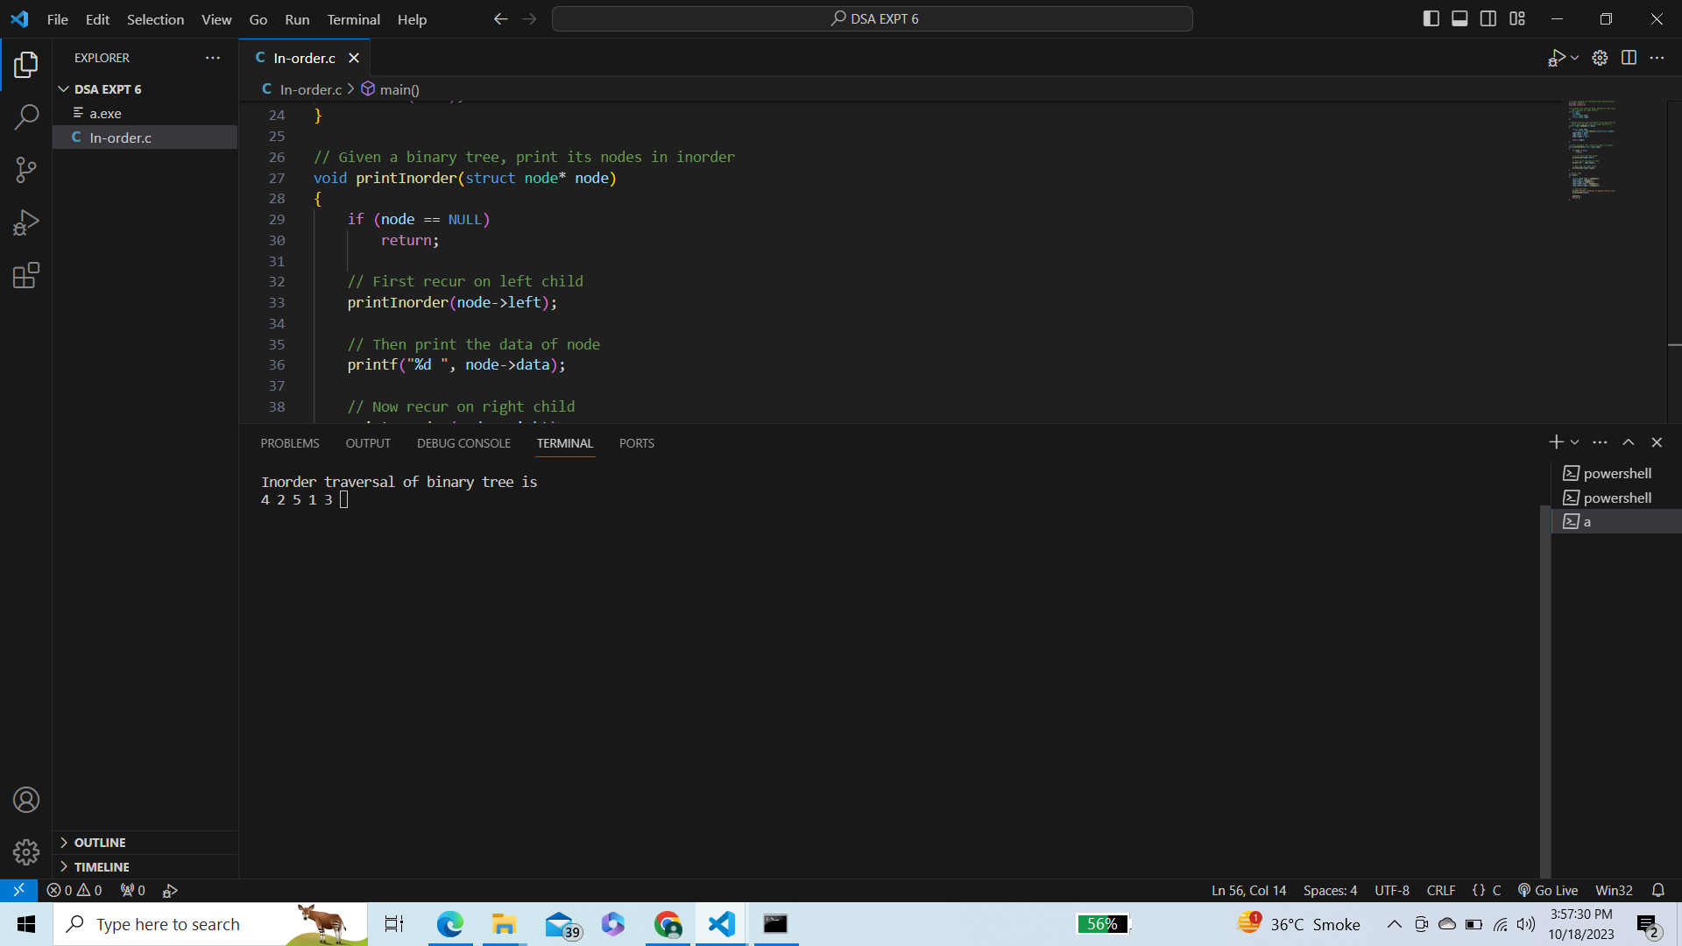

/\* \*\*\*\*\*\*Pre-order Traversal\*\*\*\*\*\* \*/

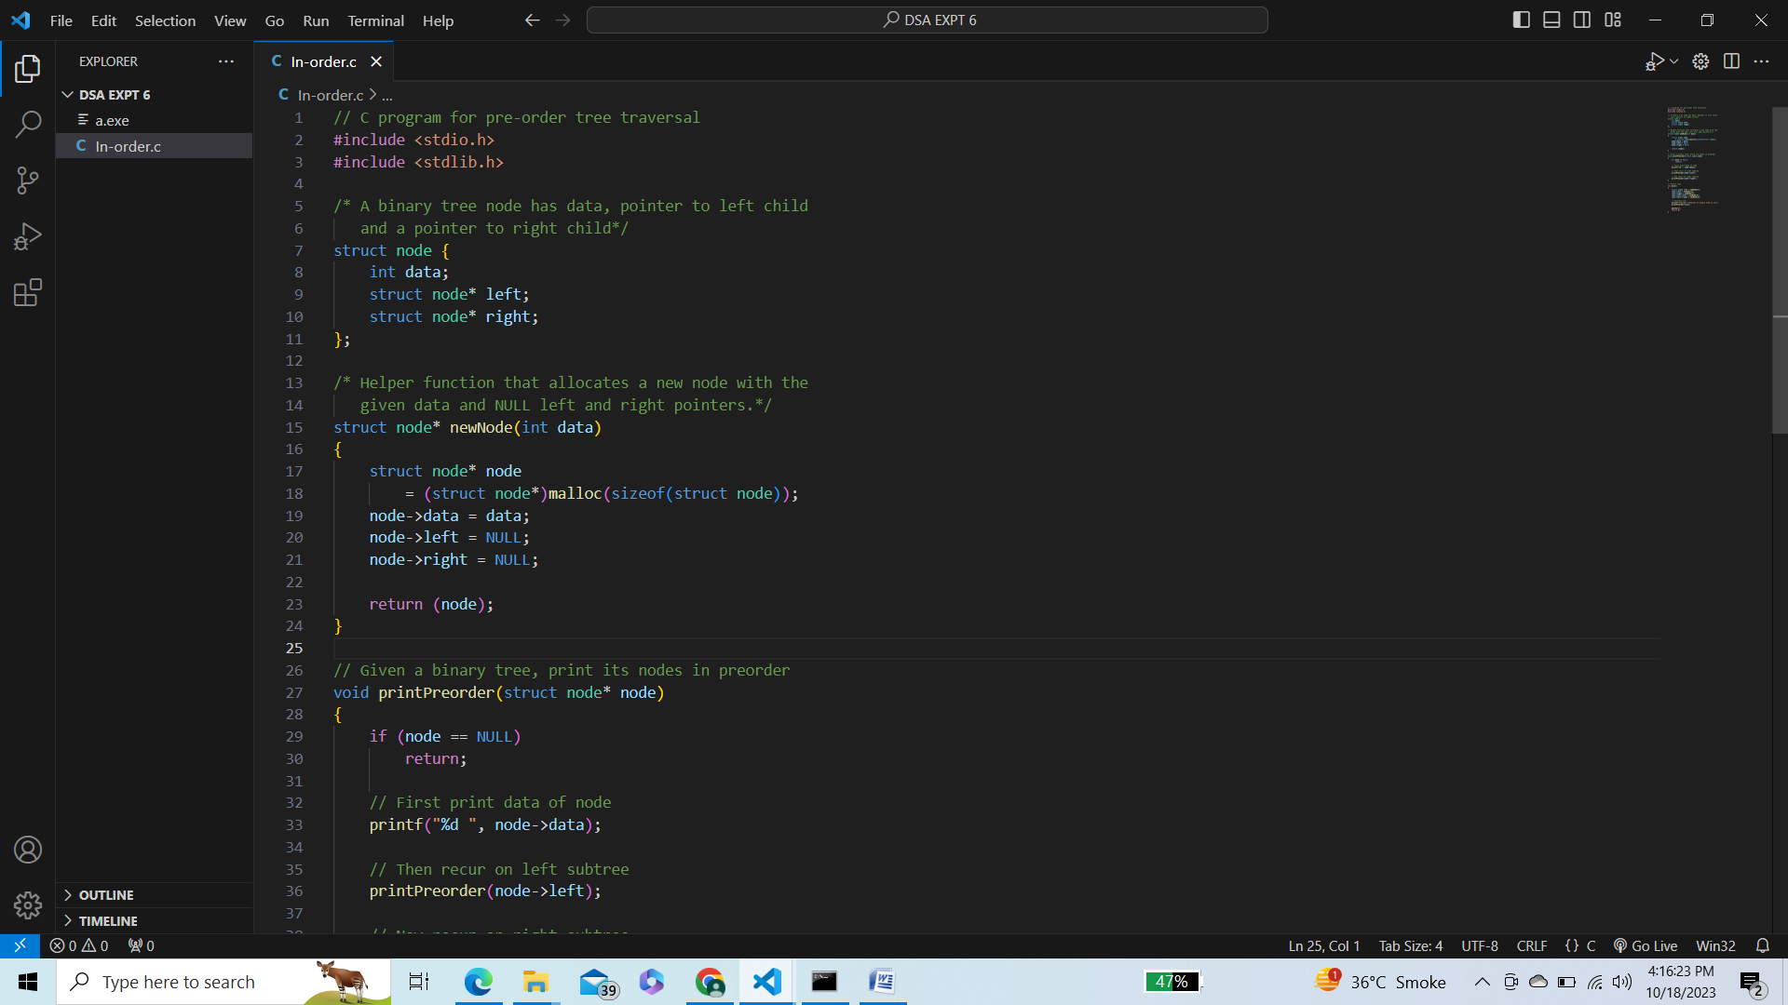

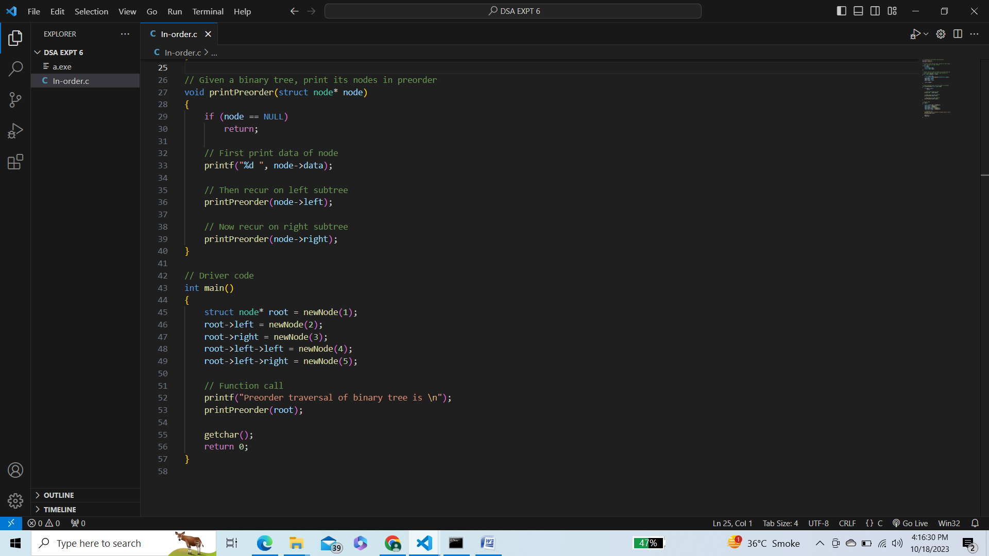

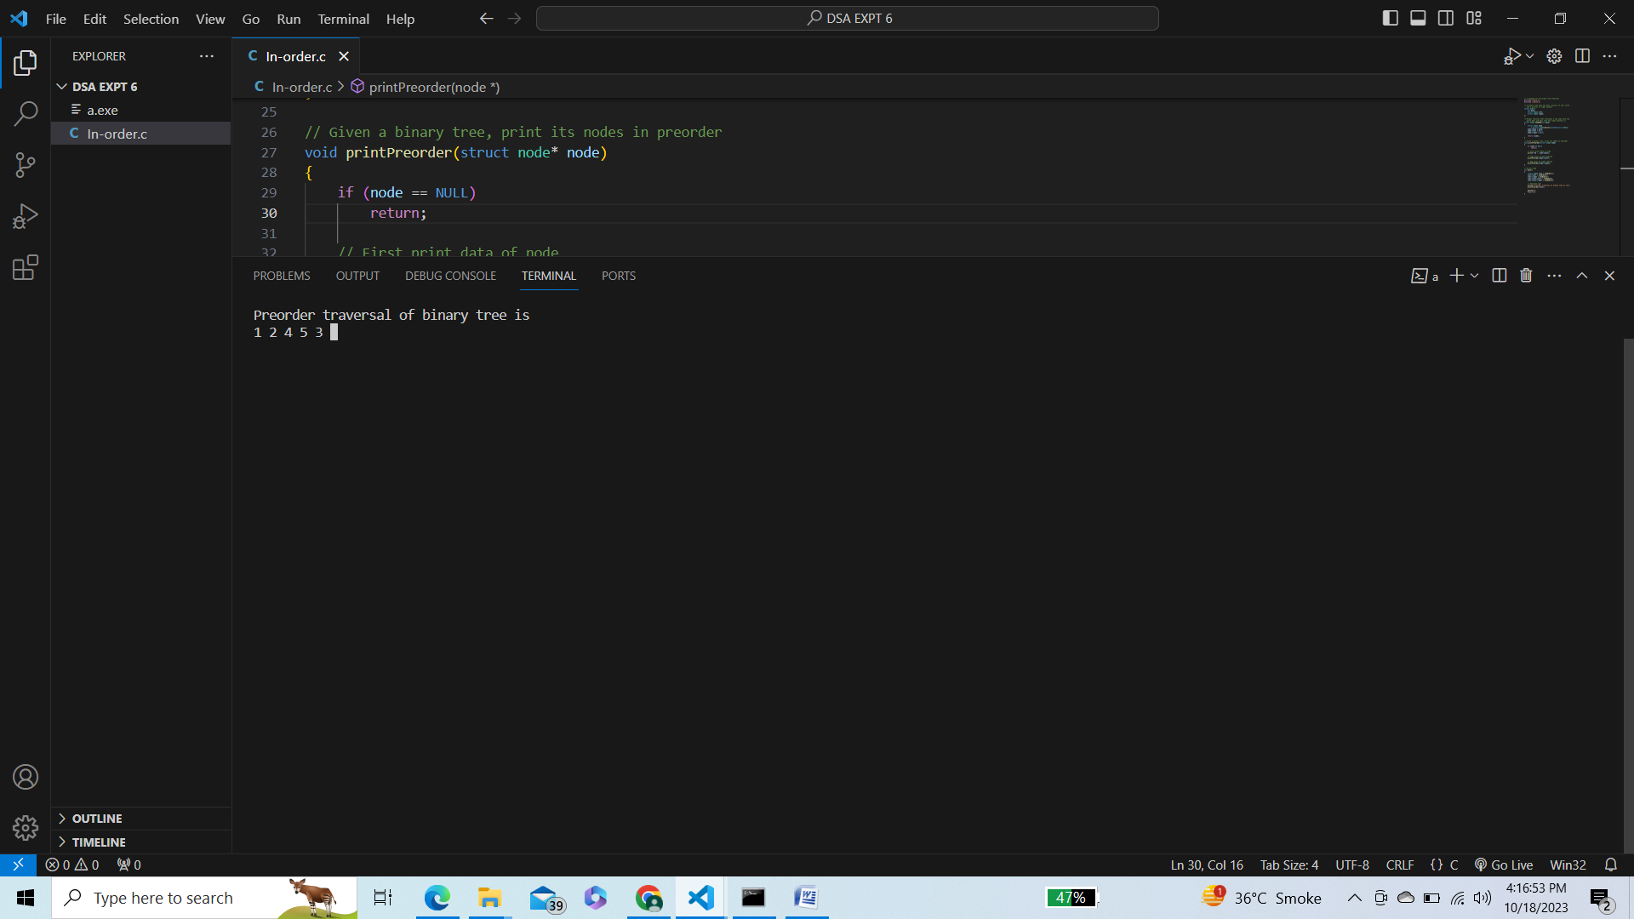

/\* \*\*\*\*\*\*Post-order traversal\*\*\*\*\*\* \*/

